
SCHOOL OF COMPUTING AND ENGINEERING SCIENCES (SCES)
BACHELOR OF SCIENCE IN ELECTRICAL AND ELECTRONICS ENGINEERING (BSEEE)
CIRCUIT THEORY II LAB III:
DETERMINE AND PLOTTING THE FREQUENCY RESPONSE OF A LAG NETWORK
BY:
Mwongela Edward Aribu
COLLABORATORS:
Mwichigi Samuel Ng’ang’a.
Nyamoro Sonya Esther.
Gichuhi Ted Mbugua.
LECTURER:
PROF. ENG JACKSON MBUTHIA.

INTRODUCTION

METHODOLOGY

Objectives
Use Arduino code as a sinusoidal function generator and plot the frequency response of the lag network.
Determine the frequency response of lag network using the Arduino as a variable frequency source

Prerequisites
Obtaining the voltage gain formula for the lag network shown below:
Voltage gain= Vo(s)Vi(s)
For the inverting op amp, v0t= -RfRi. vit
For the first op amp, v1= -R21+jωR2C2R11+jωR1C1. Vi
Vo= -R4R3.-R2+sR1R2C1R1+sR1R2C2. Vi
VoVi=R4R3. R2+sR1R2C1R1+sR1R2C2
Vo(ω)Vi(ω)=R4C1R3C2.s+1R1C1s+1R2C2

Materials needed for the lab experiment.
- Arduino Uno
- Jumpy wires
- Resistors
- 8.2k ohm(2)
- 33k ohm
- 10k ohm
- Capacitors
- 470uF
- 10nF
- 8.2nF
- Solderless Breadboard
- Oscilloscope
- 2 Op-amps (741)

CIRCUIT DIAGRAMS, THEORETICAL ANALYSES, SAMPLE CALCULATIONS AND SIMULATIONS

Sample Calculations and Bode plots of the frequency response
Using MATLAB to plot the bode Frequency Response the following were the obtained
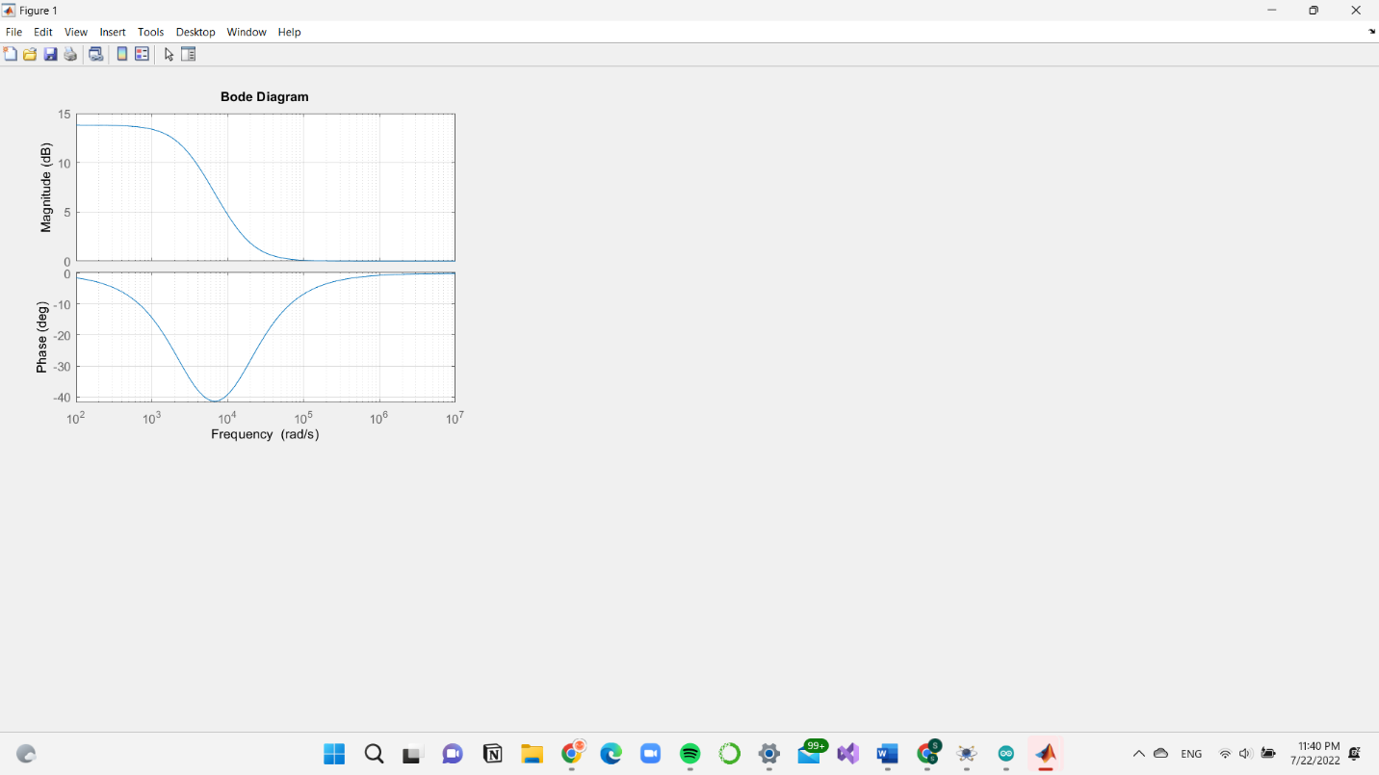

 | 0.1 | 1 | 10 | 100 | 1000 | 10000 | 100000 | 1000000 | 10000000
10log (14872.12+2) | 83.45 | 83.45 | 83.45 | 83.45 | 83.47 | 85.07 | 100.09 | 120 | 140
10log (2 +3030.32) | -69.62 | -69.62 | -69.62 | -69.63 | -70.07 | -80.38 | -100 | -120 | -140
20log |T(ω)| | 13.83 | 13.83 | 13.83 | 13.82 | 13.4 | 4.69 | 0.09 | 0 | 0
arctan 3030.3 | 0 | 0 | 0 | 0 | 4.0 | 34.4 | 81.4 | 89.4 | 90.0
14872.1 | 0 | 0 | 0 | -1.8 | -18 | -73.3 | -88.2 | -89.8 | -90
∠T | 0 | 0 | 0 | -1.8 | -14 | -38.9 | -6.8 | -0.4 | 0

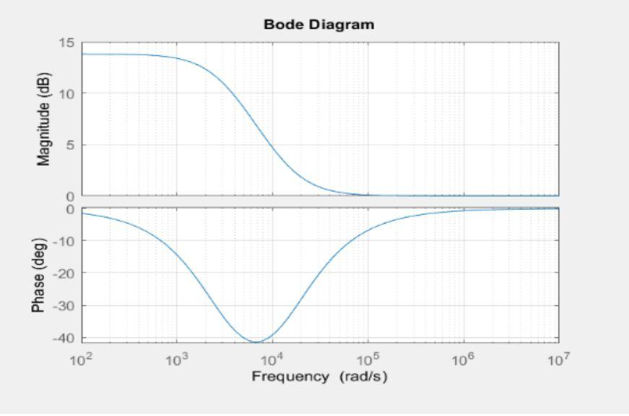

Simulation of design

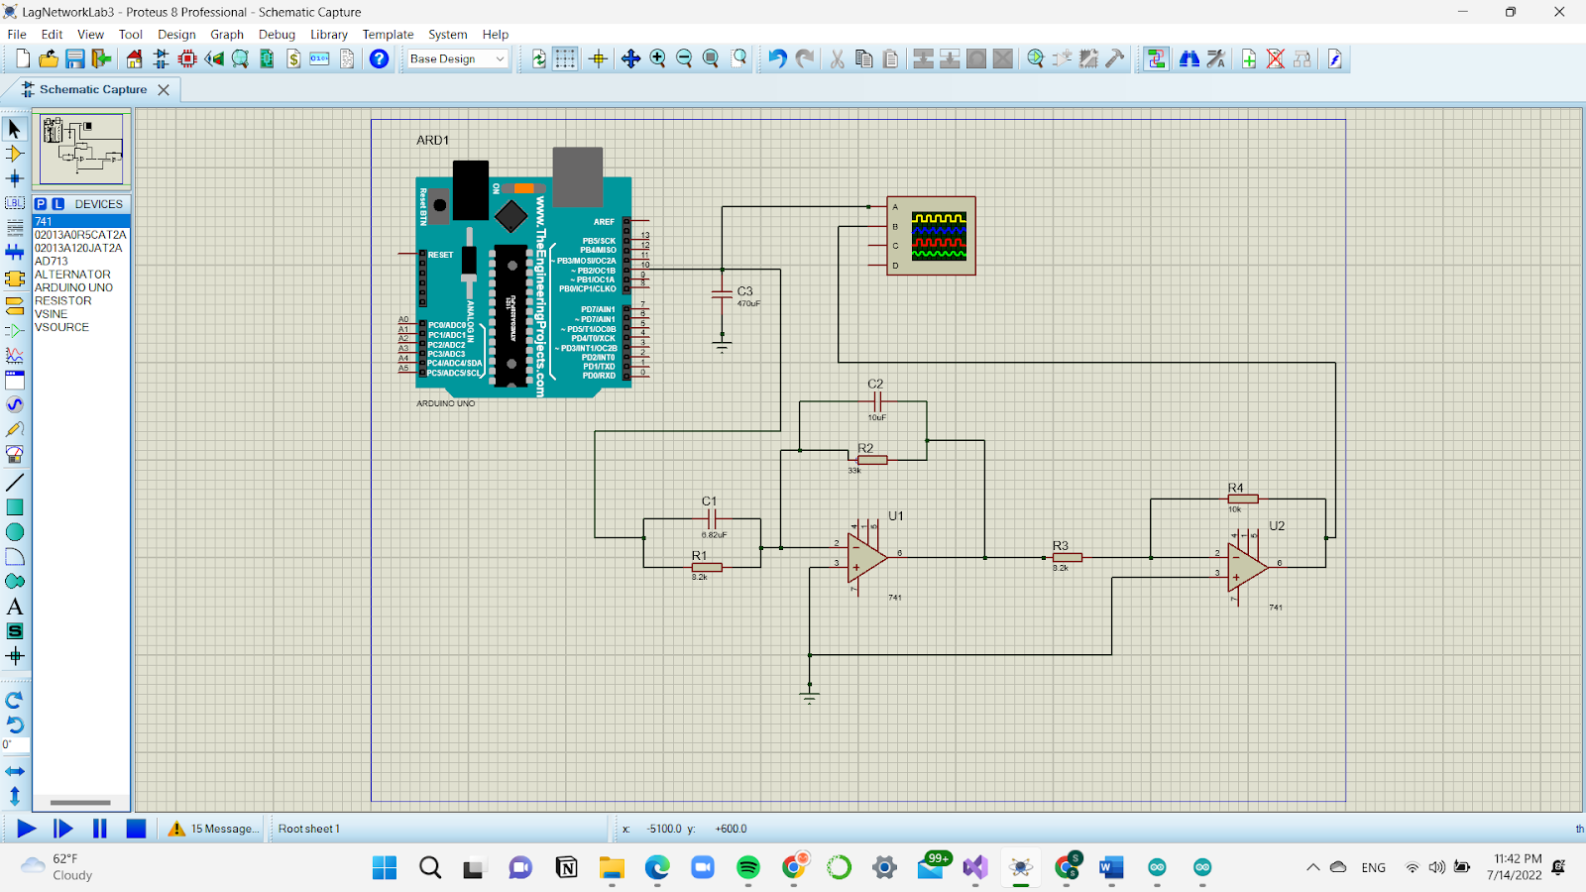

Experimental design of the Arduino sine wave generator
Arduino code used for the simulation is as shown:
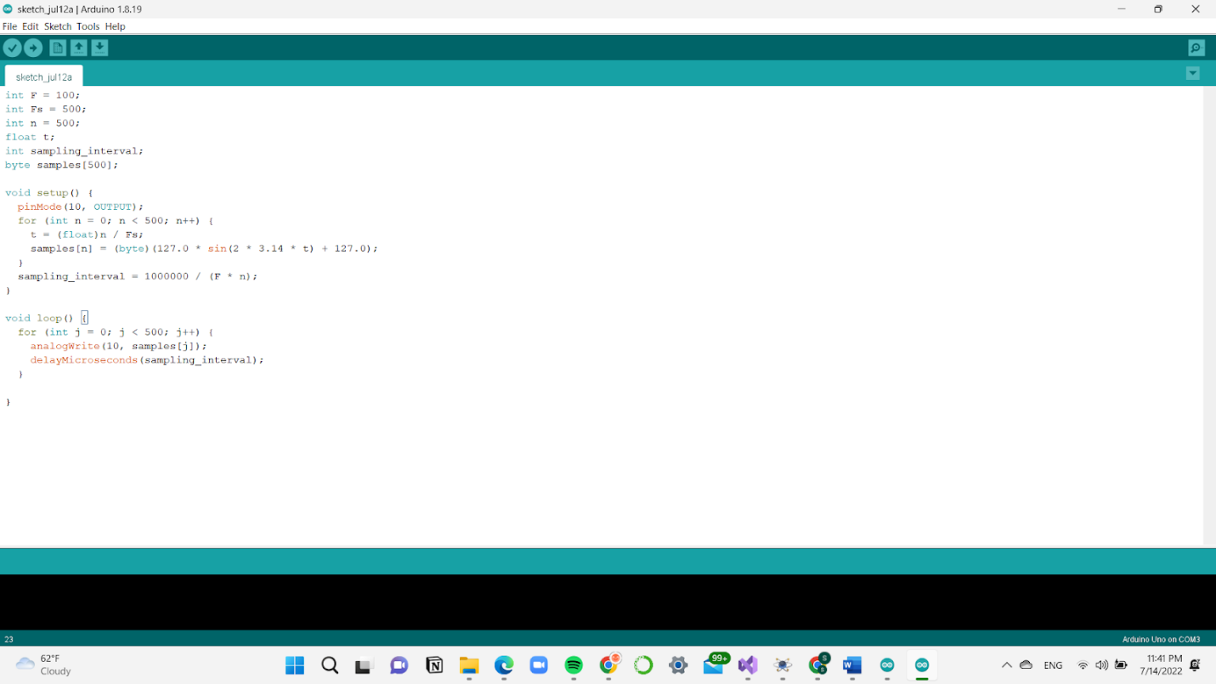

Using the output of the Arduino sine wave generator as the input to the lag network designed, the observed values from simulation are as shown:

rads | 100 | 1,000 | 10,000 | 100,000 | 1,000,000
Vi() | 4.31 | 4.31 | 4.31 | 4.31
VO(ω) | 3.77 | 3.83 | 3.99 | 4.01
Voltage gain (Experimental) | 0.874 | 0.875 | 0.931 | 0.939
Voltage gain(calculated) | 0.801 | 0.875 | 0.931 | 0.939

The waves obtained are as seen below:
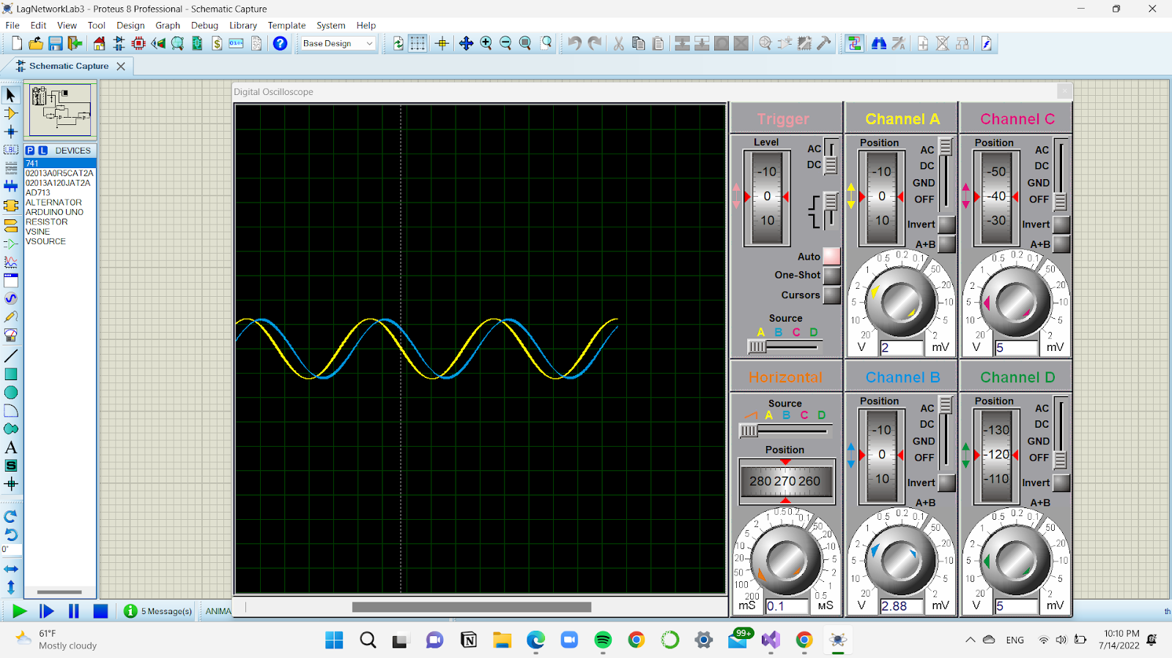

EXPERIMENTAL SETUP, RESULTS AND GRAPHS

rads | 100 | 1,000 | 10,000 | 100,000 | 1,000,000
Vi() | 4.31 | 4.31 | 4.31 | 4.31
VO(ω) | 3.77 | 3.83 | 3.99 | 4.01
Voltage gain (Experimental) | 0.874 | 0.875 | 0.931 | 0.939
Voltage gain(calculated) | 0.801 | 0.875 | 0.931 | 0.939

CONCLUSIONS
- We were able to achieve the objectives of the experiment which was to be able to plot a frequency response Bode plot of a lag network.
- A challenge faced during the experiment was inadequate number of oscilloscopes in the laboratory.

References
https://electronics-fun.com/arduino-sine-wave-generator/

VIDEO UPLOAD
https://drive.google.com/drive/folders/1aPPNghbNxIhP_d2MGY8iZ_bv8CX7irBy

